USER MANUAL
CS175
ANDROID

SUBMITTED TO:
Mr. Paul John Parreño

SUBMITTED BY:
John Efraim P. Pateres
Mary Stephann Y. Repollo

SUBMITTED ON:
March 15, 2014

Table of Contents

COVER PAGE 1
INTRODUCTION 6
LOGIN PAGE 7
SIGN UP PAGE 8
HOME PAGE 9
PROFILE/POST PAGE 10
COMPOSER 11
EDIT A BLOG/POST 12
ATTACHMENT 13
CHANGE/EDIT PICTURE 14
INTENT PROFILE (Following) 15
INTENT PROFILE (Followers) 16
FOLLOWING PAGE 17
FOLLOWERS PAGE 18

Table of Figures

Figure 1: LOG IN PAGE 7
Figure 2: SIGN UP PAGE 8
Figure 3: HOME PAGE 9
Figure 4: PROFILE/POST PAGE 10
Figure 5: COMPOSER 11
Figure 6: EDIT A BLOG/POST 12
Figure 7: ATTACHMENT 13
Figure 8: CHANGE/EDIT PICTURE 14
Figure 9: INTENT PROFILE (Following) 15
Figure 10: INTENT PROFILE (Follower) 16
Figure 11: FOLLOWING PAGE 17
Figure 12: FOLLOWING SINGLE PAGE 18
Figure 13: FOLLOWERS PAGE 18
Figure 14 FOLLOWERS SINGLE PAGE 18

Table of Revision

COVER PAGE 1
Version 1 (Feb. 23, 2014) 1
Version 2 (March 6, 2014) 1
INTRODUCTION 6
Version 1 (March 4, 2014) 6
Version 2 (March 6, 2014) 6
Version 3 (March 7, 2014) 6
LOGIN PAGE 7
Version 1 (March 6, 2014) 7
Version 2 (March 7, 2014) 7
SIGN UP PAGE 8
Version 1 (March 6, 2014) 8
HOME PAGE 9
Version 1 (March 6, 2014) 9
Version 2 (March 7, 2014) 9
PROFILE/POST PAGE 10
Version 1 (March 6, 2014) 10
Version 2 (March 7, 2014) 10
Version 3 (March 15, 2014) 10
COMPOSER 11
Version 1 (March 6, 2014) 11
Version 2 (March 7, 2014) 11
EDIT A BLOG/POST 12
Version 1 (March 6, 2014) 12
ATTACHMENT 13
Version 1 (March 6, 2014) 13
CHANGE/EDIT PICTURE 14
Version 1 (March 6, 2014) 14
INTENT PROFILE (Following) 15
Version 1 (March 6, 2014) 15
Version 2 (March 7, 2014) 15
Version 3 (March 15, 2014) 15
INTENT PROFILE (Followers) 16
Version 1 (March 6, 2014) 16
Version 2 (March 7, 2014) 16
Version 3 (March 15, 2014) 16
FOLLOWING PAGE 17
Version 1 (March 6, 2014) 17
Version 2 (March 7, 2014) 17
Version 3 (March 15, 2014) 17
FOLLOWERS PAGE 18
Version 1 (March 6, 2014) 18
Version 2 (March 7, 2014) 18
Version 3 (March 15, 2014) 18

INTRODUCTION

Wanderlost application is a travel blog application which the blogger or the person who love to write or exposed there story of their travel experience in the world, also the blogger can follow other bloggers which they can get some of the travel guides and places.

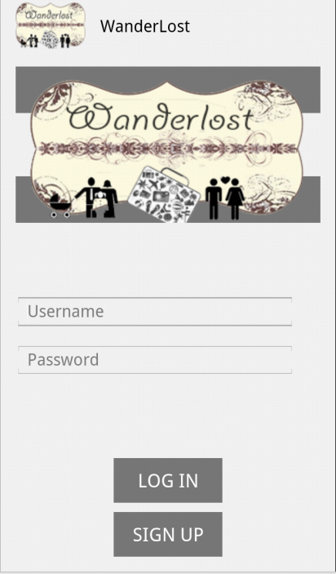
Figure 1
LOG IN PAGE
The LOGIN PAGE contains the logo of the blog, picture, username and password text field, log in and sign up button. The LOG IN button will direct the user to the HOME PAGE implemented using fragments while the SIGN UP button will direct to the SIGN UP activity page.
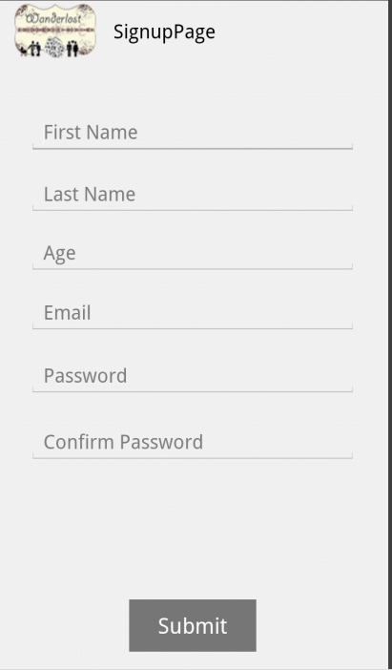
. Figure 2
SIGN UP PAGE
The SIGN UP page contains the logo and the basic information of the user like first name, last name, age, email, password, and confirm password text fields with a submit button which will direct it to the HOME PAGE implemented via fragments after filling up the fields.

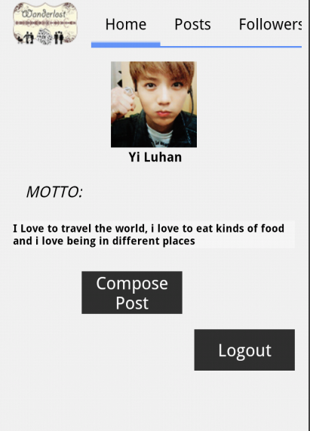
Figure 3

HOME PAGE
The HOME page activates the HOME tab and it contains the profile picture of the user, below the picture is the name of the user, its motto, a button namely CREAT POST which will redirect to COMPOSER and a LOG OUT button that will direct to the LOGIN page. Above you can see the slide tab hosts namely HOME, PROFILE, FOLLOWING and FOLLOWERS. These tabs will direct to its own designated fragment page.

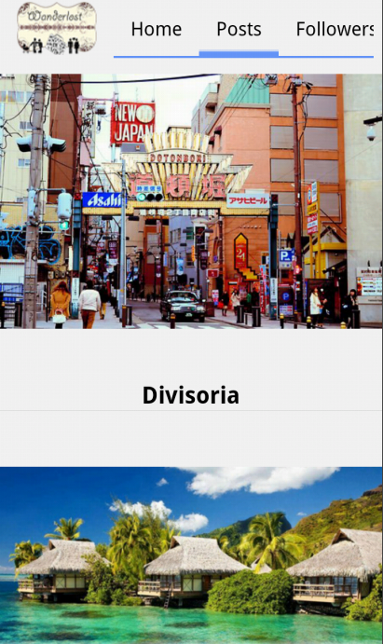
Figure 4

PROFILE/POST PAGE
The POST page is a fragment implemented page where it contains a listview of pictures of the places the blogger travels, beside is the is the pictures name and location when its clicked there will be an intent page where it contains more information about the picture itself
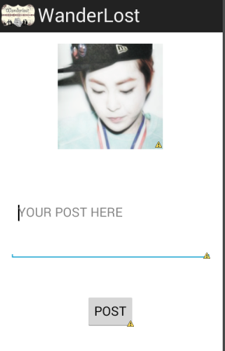
Figure 5

COMPOSER
The COMPOSER page is a page where users can write something to post. This page is an intent type from the button CREAT POST where it is found under the POST PAGE. Below the text field you will find the POST button where when the user done writing something he/she clicks the button and it will redirect to POST PAGE where user can find the post message of others.

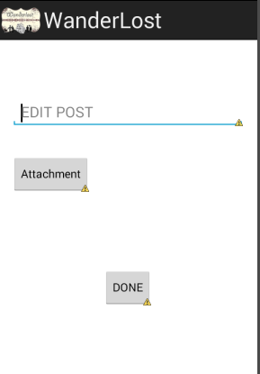

Figure 6

EDIT A BLOG/POST
The EDIT A BLOG page is a page under the post tab where the user can edit his/her post and can attach a file via attach file button that directed to ATTACHMENT page where the user can attach a text, video, or picture together with its post and then a DONE button will direct to HOME page.
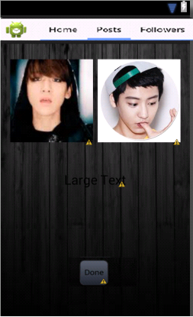
Figure 7

ATTACHMENT
The ATTACHMENT page is a page where the user can attach a text, video, or picture. The user can choose from the existing files to be attached and the DONE button will direct to the EDIT A BLOG page where it shows that the user has chosen the appropriate file he/she wants to go with the post.
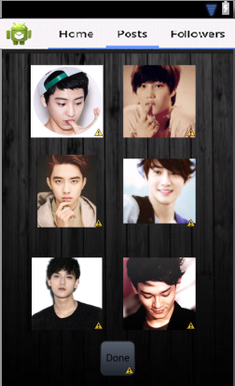
Figure 8

CHANGE/EDIT PICTURE
The EDIT PICTURE page is a page where the user can choose any picture to replace its old profile picture. Here are some samples of images where the user can choose from and the DONE button will redirect the user to the PROFILE page.

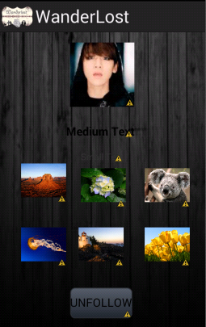
Figure 9

INTENT PROFILE (Following)
The INTENT PROFILE page for following is a page where the user can see the details of the picture he/she is following and below is a list view of related travel photos. Below you will find the UNFOLLOW button where the user choose whether he/she want unfollow the picture. Once the button is click it will change to FOLLOW button. .
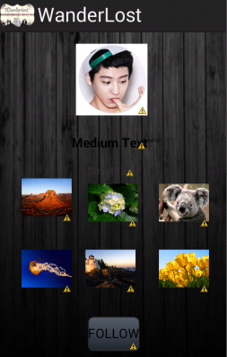
Figure 10

INTENT PROFILE (Followers)
The INTENT PROFILE page for followers this is a page where the user can see the details of the people follows him/her, below is a listview of other related travel pictures from the users together with their detailed information. At the bottom you will find the FOLLOW button where the users choose whether he/she want follow that person. Once the button is click it will change to UNFOLLOW button. Similar to the intent for following.

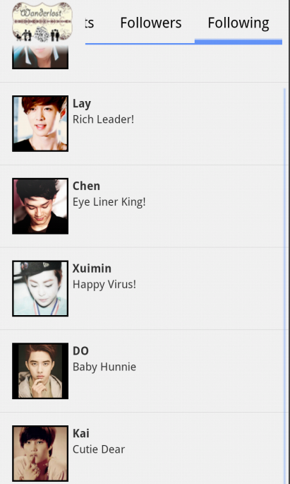
Figure 12

FOLLOWING PAGE
The FOLLOWING PAGE is a page of a listview pictures about places of those people the user is currently following together with their details like name and location. Each of which is clickable and once clicked it will redirect to an intent page to show more detailed info about the pictutre.

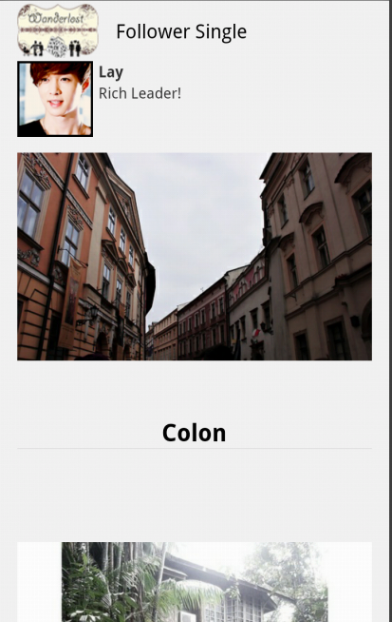
Figure 12

FOLLOWING SINGLE PAGE
The FOLLOWING SINGLE PAGE is a page of the people who follow your blog, you can see the posts, the picture and the places where they travel
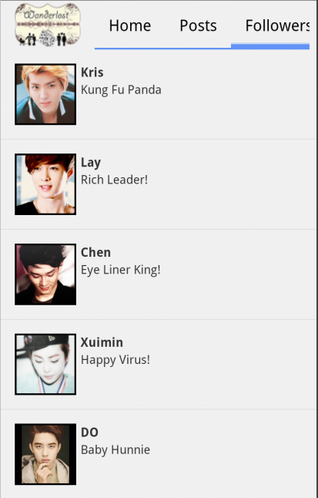
Figure 13

FOLLOWERS
The FOLLOWER Page is a page also a listview of pictures from the people wo wants to follow the user also each of these picture is clickable and can be link in an intent page where the user can see more detailed information about this picture.
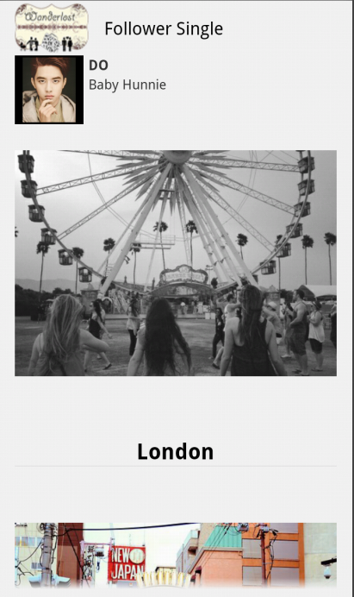
Figure 14

FOLLOWERS SINGLE PAGE
The FOLLOWERS SINGLE PAGE is a page of the people who follow your blog, you can see the posts, the picture and the places where they travel

